**PHASE 1:**

1. **Statement**

It is required to create software for an international airline with worldwide coverage.

The program must load the airports available in the airline through a CSV file as well as the prices between each route. The user will be able to enter the place of departure and arrival, having as an answer the price of the flight with the stopovers during the trip.

1. **Identification of the problem**

We want to develop software in which you can find the cheapest trip with its stopovers

**Needed:**

* We want to develop software in which you can find the cheapest trip with its stopovers

**Problem:** Read the starting point and the arrival point to find the most economical trip

1. Research

Functional requirements:

1. Read the CSV with the prices of the trips
2. Read the CSV with the airports available in the program
3. Find the cheapest trip with the stopovers to make

**PHASE 2:**

**Graph:** A graph in the field of computer science is an abstract data type (ADT), which consists of a set of nodes (also called vertices) and a set of arcs (edges) that establish relationships between nodes. The concept of graph TAD descends directly from the mathematical concept of graph.

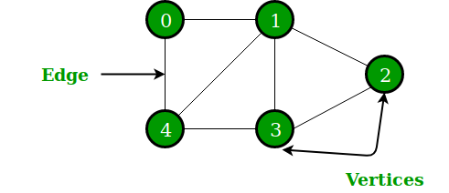Formally, a graph is defined as G = (V, A), where V is a set whose elements are the vertices of the graph and A is a set whose elements are the edges, which are pairs (ordered if the graph is directed) of elements in V.

**Disjoint sets:** In computing, a data structure for disjoint sets is a data structure that maintains a set of elements partitioned into a number of disjoint sets (the sets do not overlap). A Union-Find algorithm is an algorithm that performs two important operations in this data structure:

Search: Determines which subset an element belongs to. This operation can be used to check if two elements are in the same set.

Union: Joins two subsets into one.

The other important CreateSet operation is generally trivial, it creates a set with a given element. With these three operations, many practical partitioning problems can be solved (see the Applications section).

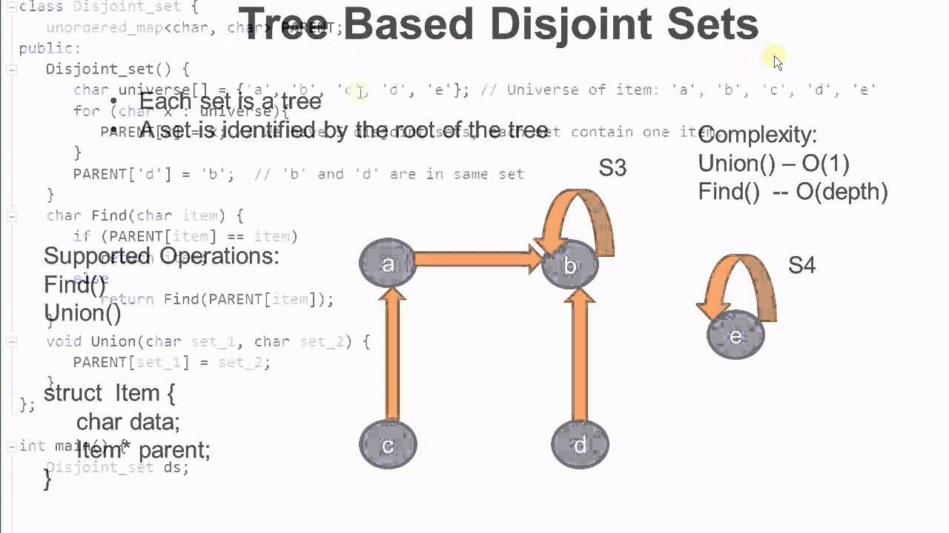In order to define these operations more precisely, it is necessary to represent the sets in some way. A common approach is to select a fixed element from each set, called the representative, to represent the set as a whole. Then Search (x) returns the representative element of the set to which x belongs, and Union takes as an argument two representative elements of two sets respectively.